Annual Parish Meeting of Ubbeston
Thursday 18th May to follow the Annual Parish Council Meeting
At Huntingfield Hub
- Introduction & Welcome by Chair of the Parish Council.
- Apologies for Absence. Apologies from Cllr Stephen Burroughes who was attending another meeting.
- To approve the minutes of the last Annual Parish Meeting. Approved
- To receive a report from the Parish Council. Cllr Pike as outgoing Chair gave a report from Parish Council. See appendix A
- To receive reports from:
  - District Councillor Appendix B
  - County Councillor Appendix C
  - MP Therese Coffey Appendix D
  - Safer Neighbourhood Team Halesworth Locality Appendix E
  - Ubbeston Recorder Report Appendix F
  - The Hub Appendix G
Thanks were expressed to Lynne Ward for managing the website.
Thanks were also expressed to Anne Martin for services of over 20 years as clerk to the Council and even longer as a Councillor. A presentation was made to show the council’s appreciation.
Meeting closed 8-30pm.

Minutes agreed as correct.

Chair____________________________________Date________________________

Appendix A
UBBESTON PARISH COUNCIL REPORT
MAY 2017

The main item this year is a change in our Parish Clerk. Anne Martin retired after over 20 years of dedicated service which we much appreciate. Our new Clerk is Julle Collett from Huntingfield who we are very pleased to have on board and look forward to a long working relationship with.

THE OTHER THINGS OF NOTE ARE: -

> Your Parish Council now meets in the Hub Huntingfield.

> Pot holes mainly on the Clay Hill road in Ubbeston have been a problem with repairs taking longer than usual.

> SID (speed identification device) is still on going and your councillors are activley pursuing options.

>Two dog fouling bins have been erected. One of them paid for by The Croft campsite the other with parish funds.

> A new Parish notice board has been attached to the bus shelter by Nigel. This was kindly paid for from funds our District Councillor Stephen Burroughes was allocated.

Finally, I would like to thank Lynne for feeding our website as and when required. Nigel for strimming and helping to keep things tidy, and Chrissie for stepping in and chairing meetings when I was unable to.

Allan Pike

Appendix B
SUFFOLK COASTAL DISTRICT COUNCILLOR’S REPORT


Cllr Stephen Burroughes April / May 2017

- BEACH HUT REVIEW CONSULTATION

As you are aware, the six-week public consultation on the Beach Hut Review has now been completed.
We received well over 700 responses. These are now being analysed and the information will be used to help formulate a new report on this issue, with proposals for the way forward. Cabinet will then consider the new report, complete with the consultation responses, later in the year. In the interim, no decisions have been taken on how the beach hut service will be managed, or what charges will be levied, in the future. The responses to this consultation will be invaluable in assisting Suffolk Coastal to shape the future of this service and make decisions on this issue.

Because the consultation period covered the time when existing beach hut owners would normally be asked if they wanted a licence for the coming financial year, the decision was also taken to issue an annual licence for a further year (2017/18), with the charges increasing by the same rate as the Council Tax for Suffolk Coastal (3.25%), while the longer term future of the service is properly debated. The beach hut service is just one of many being reviewed by the Council.

- SUPPORT ARMED FORCES DAY

A celebratory event to show appreciation of the work of the Armed Forces is to be held in Felixstowe this year. 2017 marks the 350th anniversary of the Dutch attack on Landguard Fort in Felixstowe and to mark the occasion, and to recognise the huge contribution made by our servicemen and women from the past until the present day, Felixstowe has been chosen as the venue for Suffolk Armed Forces weekend.

A weekend of action-packed entertainment is planned for Saturday 24 and Sunday 25 June 2017 and plans to be a high profile, one off free event for all age groups. There will be a unique package of entertainment including music from choirs and military bands to an evening of pop and rock, military displays, food stalls, children’s activities and fireworks, and some thrilling battle re-enactments between the Dutch and English with cannon, muskets and swords. All this by Felixstowe’s fantastic seaside with all that has to offer as well! The event is being organised in partnership by organisations including the Suffolk Armed Forces Covenant Group, the Landguard Fort Trust, Royal Marines Association and Royal British Legion, with assistance from local authorities and military units. To make this an event we can all be proud of we need the support of businesses, organisations and individuals who understand and value our armed forces, our community and our history. If you would like to talk more about how you could be involved, please feel free to give our project officer Paul Grant a ring on 07850 427928, or email: paul.grant@eastsuffolk.gov.uk

- New Volunteering Website

There is a new and easy way to discover volunteering opportunities in Suffolk, thanks to the Volunteer Suffolk website. The site has been created as a one-stop shop for people to discover how they can gift their time, and for local organisations to advertise their volunteering opportunities. The website already boasts more than 100 volunteering opportunities, added by local organisations and charities. These range from short-term and one-off roles, to temporary positions and long-term roles. Current opportunities include being a tour guide for the Tide Mill in Woodbridge, a marshal at the Midnight Walk in aid of St. Elizabeth Hospice, preparing animal feeds at Banham Zoo and assisting with play sessions for children who have suffered from domestic abuse or violence at home.

There are also “10 minute volunteer” opportunities on offer which simply involve sharing a Facebook post to raise awareness, sourcing a raffle prize or putting up a poster at work. The website also provides helpful volunteering tips, latest news and volunteers’ stories. Volunteer Suffolk is a product of the Suffolk Volunteering Strategy and was made possible thanks to a steering group of representatives from Suffolk’s public, private and voluntary sectors. For more information visit www.volunteersuffolk.org.uk

- Love East Suffolk’ returns

The ‘Love East Suffolk’ litter pick scheme is back for 2017 to encourage, enable and reward people to show some ‘love’ for the environment we live in. Last year the incentive based community litter pick scheme helped clean up over 7.6 tonnes of waste across Suffolk Coastal and Waveney whilst also giving groups funding to spend in their community. In 2017 both Councils hope to encourage even more groups to take part – beating the 2,035 people who got involved during 2016. To incentivise more groups of volunteers to help litter pick in East Suffolk, the Love East Suffolk scheme offers a £20 payment to all groups who register their litter pick to take place between 1 March to 31 May 2017.

All registered groups who carry out their pick during this period will also be entered into a prize draw, with prizes of £200 awarded to winning groups in each of five “neighbourhood areas” in Suffolk Coastal and in each of four “neighbourhood areas” in Waveney with funding once again provided by Norse. Both Suffolk Coastal Norse and Waveney Norse can provide volunteers with equipment including sacks, disposable gloves, to groups on request and will also arrange for gathered litter to be collected. Litter pick sticks, bag hoops, and green vests can also be loaned out, subject to availability.

For more information, visit: www.eastsuffolk.gov.uk/waste/litter/love-east-suffolk
- Return, recycle, reuse
The NHS has launched a community equipment amnesty across Suffolk to get people to return as much unused NHS equipment as possible during March. Anything including crutches, walking frames and mattresses, can be returned easily as part of a month-long NHS amnesty from 1 to 31 March 2017. You can also contact your local surgery or hospital to arrange this at other times.
Last year local health services issued over 100,000 NHS community equipment items to Suffolk patients in need at a cost of more than £8.5m. By the end of the year nearly 40,000 items, costing £3.4m, had not been returned to the contractor Medequip. While some patients need equipment for long periods of time, NHS services lose thousands of pounds each year due to missing equipment. Some of the equipment the NHS is keen to get back includes alternating air mattresses, which cost £1,650 each, and wheeled adjustable frames, costing £12.70 each. In one month alone last year, nearly £8,500 worth of wheeled adjustable frames and nearly £600,000 worth of air mattresses were issued by Suffolk NHS services.
NHS equipment can be returned to any of the Medequip locations listed below, Monday to Friday from 8.30am to 5.00pm. As part of the month-long NHS equipment amnesty the Medequip sites will also open every Saturday 8.00am to 2.00pm.
Bury St Edmunds Depot  Unit 3 Bunting Road  Bury St Edmunds  Suffolk  IP32 7BX | Ellough Depot  Unit 1a, The Moor Business Park  Benacre Road  Ellough, Beccles  Suffolk  NR34 7TQ | Ipswich Depot  Unit 31, Bluestem Road  Ransomes Europark,  Ipswich  Suffolk  IP3 9RR
For those unable to drop off at collection points, Medequip will collect items for free. Contact Medequip on 01473 351805 to arrange a suitable time for collection. The Medequip collection service is available long-term, alongside its weekly openings at its depots, and not only as part of the March amnesty.

For further information or to ask questions etc. I can be contacted at: stephen.burroughes@suffolkcoastal.gov.uk

Cllr Stephen Burroughes
District Councillor for Peasenhall & Yoxford Ward
Suffolk Coastal District Council

Appendix C

SUFFOLK COUNTY COUNCILLOR’S REPORT

BY STEPHEN BURROUGHES - APRIL - MAY 2017
- Architects selected for Upper Orwell Crossing

Following a competition run in partnership with the Royal Institute of British Architects (RIBA), Suffolk County Council is very pleased to announce that Foster + Partners has been selected as the architectural team to join the Upper Orwell Crossings project in Ipswich. The crossings will be the second project Foster + Partners has undertaken in the town, following the construction of the architecturally significant Willis Building in Ipswich town centre.

The Panel, chaired by Sir Michael Hopkins CBE, selected Foster + Partners from a strong shortlist of five internationally renowned teams that included (in alphabetical order of design firm lead): Adamson Associates with William Matthews Associates and Ney & Partners; Knight Architects; Marc Mimram; and Wilkinson Eyre with FHECOR and EADON Consulting. Foster + Partners impressed the panel by the quality of their overall approach and thinking, including the initial design concepts presented for the project’s three crossings. The approaches were considered to have the potential to enhance Ipswich’s thriving waterfront, as well as acting as a catalyst for regeneration of the wider harbour area.

The county council and key partners, including Ipswich Borough Council and Ipswich Vision, keenly anticipate seeing the initial design ideas developed further with the wider project team and in consultation with local businesses, communities and residents. Competition concept design images can be downloaded from here https://www.flickr.com/photos/suffolkcountycouncil/

A video is also be available online at www.youtube.com/user/SuffolkCC

- Suffolk Fostering and Adoption launch new approach to support foster families

Suffolk Fostering and Adoption Service is launching the Mockingbird Family Model of foster care in Suffolk, in partnership with The Fostering Network.

The Fostering Network has already introduced the pioneering Mockingbird Family Model to the UK, and it has been piloted with 7 organisations across the country since April 2015. They have now been successful in securing an additional £3.76m in funding through the Department for Education’s Children’s Social Care Innovation Programme to extend the model to a further 5 organisations in the UK, including Suffolk Fostering and Adoption Service.

The model was developed by The Mockingbird Society in the USA and is based on the idea of an extended family. It uses a ‘constellation’ where 6 to 8 fostering ‘satellite’ households living near each other are offered support from a dedicated ‘hub home’ fostering household of specially recruited and trained carers. The hub home carer offers regular planned respite care and emergency respite care to the satellite carers. They will also assist with peer support, regular joint planning and social activities. Relationships are central to the model, with hub carers and foster carers providing frontline care and with social workers able to concentrate on successful relationship building. For more information about how to become a foster carer in Suffolk, visit www.fosterandadopt.suffolk.gov.uk

- Bury St Edmunds to receive £2.8million for sustainable transport schemes

A significant transport investment scheme to improve facilities for walking and cycling in Bury St Edmunds is being announced today. A total of £2.8million is being spent on sustainable transport schemes, which will also accommodate increased car demand associated with growth in the town. The project, jointly funded by New Anglia Local Enterprise Partnership and Suffolk County Council, will be delivering the first four schemes in the town over the next 12 months. The schemes include:

Parkway/Cullum Road
- Replacement of two mini roundabouts with single roundabout.
- Signal upgrades.
- Widen pedestrian footways.

Tollgate Lane roundabout
- Improve flow of gyratory
- Signal upgrades.
Signalisation of Tayfen Road roundabout and improvements to Northgate roundabout
- Improve facilities for pedestrians and cyclists to cross Tayfen Road
- New cycle infrastructure, such as cycleway provided on Out Northgate Street and Toucan crossing installed on Northgate roundabout/Tayfen Road
- Widening of some vehicular approach lanes.

Spread Eagle Roundabout
- Signal upgrade to make the junctions more efficient
- Some reconfiguration of crossings to allow better pedestrian and cycle movement.

Works on the schemes will be phased to start at different periods to avoid major disruption to the town. The first development is sue to start in the summer, with the final project due to be completed by April 2018. All four projects are part of a package specifically planned for Bury St Edmunds, with other transport plans being developed for delivery in the future.

- Community Fire Volunteers wanted by Suffolk Fire and Rescue

Suffolk Fire and Rescue Service are currently on the lookout for enthusiastic and caring people who want to make a difference to their community. Community Fire Volunteers are fully trained volunteers who share fire safety advice in their area, visiting elderly and vulnerable people in their homes to undertake a Safer Home Visit for them, fitting smoke alarms if required and offering fire safety advice. Those who become Community Fire Volunteers will also be able to get involved in other ways, such as attending community events and fairs or giving talks to community groups about fire safety. Applicants must older than 18 years old and be available for at least 12 hours every month. Volunteers will receive ongoing training and uniform for when they undertake their duties. Support will also be given to allow volunteers to extend their skills and expenses will be paid to cover any costs incurred while on duty.

To download an application form and information pack go to https://www.suffolk.gov.uk/suffolk-fire-and-rescue-service/working-and-volunteering-for-fire-and-rescue/apply-to-be-a-community-fire-volunteer/ or call 01473 260588. The vacancy is also available on the Volunteer Suffolk website at http://volunteersuffolk.org.uk/

- Travel in time – online!

Suffolk Record Office now offers online resources at www.suffolkarchives.co.uk to help you search for a particular person or piece of information. The new website allows users to access catalogues for the records from the comfort of their own home and means many more people will be able to use the service.

Since December, residents both inside and out of Suffolk have been able to purchase and download digital copies of wills and request quotations for copies of other documents and photographs. More records are being digitised and added to the collection on an on-going basis. To find out more about the services available online, visit www.suffolkarchives.co.uk

In January, Pringle Richards Sharratt were announced as the design team behind the planned heritage centre, ‘The Hold’. ‘The Hold’ will house 900 years of Suffolk’s historical archives and is expected to open in 2019. As well as providing a teaching and research space, it will also form a unique visitor attraction and important cultural resource for the community. For more information about the project, visit www.suffolkarchives.co.uk/the_hold.

- Suffolk recognised in inclusive education award
Suffolk SACRE has received a Special Commendation for its Teaching Controversial Issues Toolkit. Suffolk County Council's Standing Advisory Council for Religious Education (SACRE) has been recognised in a national award celebrating those SACREs that work hardest at promoting the growth of mutual understanding between those of different religious beliefs.
Each local authority in England and Wales is required to convene a SACRE that monitors the assemblies and Religious Education (RE) that are taught in most local schools. Though often overlooked, SACREs can have a crucial role in boosting the growth of respect and empathy between those of different religions and beliefs, given the potential of high quality RE to advance these aims.
The Suffolk SACRE has been granted a Special Commendation by judges of the 2017 Accord Inclusivity Award for its 'Teaching Controversial Issues Toolkit', which seeks to give confidence and offer practical guidance to local teachers in delivering controversial issues linked to:
- A School and teacher's ‘Prevent’ duty to stop people being drawn into terrorist-related activity
- A School's obligation to promote pupils' Spiritual, Moral, Social and Cultural (SMSC) development
- The requirement on schools to teach Fundamental British Values (of democracy, the rule of law, individual liberty, and mutual respect for and tolerance of those with different faiths and beliefs)
The toolkit was produced with support from Suffolk County Council's Localities and Partnerships team who secured Prevent grant funding from the Home Office. This funding was used to commission the work, project managed by the SACRE, which drew on established relationships it had forged with members of local religion as well as belief groups and classroom teachers. The SACREs work included consulting with local teachers about their needs and wishes from the proposed resources.
The SACRE's flexible and non-prescriptive kit provides a ‘6 Step Plan’ to structure the delivery of sensitive and controversial issues, and is accompanied by a bank of resources to support teachers, which focus on 9 themes related to the Prevent duty. The nine themes are: sense of belonging; terrorism; extremism; hate crime; tolerance; being British; radicalisation; world events; culture and faith.
- Public Health Suffolk WANTS TO HEAR FROM YOU!

A consultation has been launched to help shape the future of pharmacy services across Suffolk. The questionnaire has been opened to enable Suffolk residents to provide feedback on pharmacy services across the county. The views, experiences and opinions of respondents will be fed into a wider piece of work that is looking at the health needs of Suffolk, the level of accessibility of pharmacy services and how these will be maintained and developed moving forward.

The survey can be accessed on www.healthysuffolk.org.uk and the closing date is Friday 31 March 2017. Hard copies of the questionnaire can be requested by emailing healthandwellbeing@suffolk.gov.uk or by telephoning 01473 260079. Any information provided will be treated as confidential.

For further information or questions please contact me at: stephen.burroughes@suffolk.gov.uk


Cllr Stephen Burroughes
County Councillor for Framlingham
Vice Chairman of Suffolk County Council

Appendix D
Appendix E

Appendix F

UBBESTON RECORDER REPORT 2016
Campsite: It has been a mixed chapter in the ongoing saga of the campsite at Ubbeston. The Secretary of State granted the owners of the land permission to open a campsite but with restrictions such as the site was not to exceed 30 pitches (the original application was for 48) and there was to be no amplified music. The business opened on 27th May this year and the restrictions have gone some way to avoiding total intrusion into the locals’ lives but those living nearest to the campsite have been inconvenienced – not surprisingly – more than doubling a population, however temporarily, has to have an impact. However, the good news for the owners is that the published comments indicate that the very things the owners have had to compromise on – number of pitches, space, amplified noise – have proved popular selling points with their clients!
Local Hero: Nick Edwards, local Ubbeston resident, started the gruelling Marathon des Sables in the Sahara Desert on the 8th April this year, not only as a personal challenge but as an opportunity to raise awareness, and funds, for two very important charities (SANE and MAP). Below is the website’s description of the event. www.marathondessables.co.uk
The Marathon des Sables is the stuff of legends. It is the Toughest Footrace on Earth (Discovery Chanel). MdS is a truly gruelling multi-stage adventure through a mythical landscape in one of the world’s most inhospitable environments – the Sahara Desert. You have to be self-sufficient and carry all your own food and equipment for the week on your back. Communal goat’s hair Berber tents are pitched every night but apart from that you have to take it with you. Water is rationed and if you exceed the ration, you get a time penalty.
In just six days you will run over 250km (156 miles) through endless dunes, over rocky jebels,[rocky mounds] and across white-hot salt plains. The sun will be your constant enemy with temperatures regularly reaching 50 centigrade. The sand will be your constant companion, clouds of it under your feet, sheets of it stinging your eyes and lots of it chafing ibidmorning, into the dusk and then the dark, many not finishing the 80+km (52 miles) till well into the next day. Your feet will swell, crack and bleed under the pressure and the heat. But none of this will matter when you cross the finishing line – a hero.
Nick began the adventure with a commitment to long hours of tough training in all weathers back in the UK. In the Sahara, Day 1 saw him running 20 miles for 8 hours over the tallest dunes in Africa carrying 13 kgs. The marathon was through never ending dunes, a 40 mph head wind, dust storms, sand everywhere, eyes, teeth, clothes impossible to get clean. As one of the last to arrive at the communal tent, Nick had to endure a night next to the tent opening where the wind and sand blows in all night.
Day 2’s itinerary was 26 miles in 8½ hours with a following day of 22 miles over a Martian landscape which resulted in blisters and a lost toenail. This was followed by the most gruelling challenge of all – 50 miles for 22 hours, day and night, with temperatures reaching 40º C - jebels, endless sand dunes, hills with sharp rocks that would snap your ankle in a heatbeat … plus baked mud flats that just never ended.
By Day 6 Nick had completed the challenge running on fumes. Not only was Nick a celebrity here in Suffolk but also in his birthplace, Trinidad, where he was featured in the local newspaper, The Guardian, and touted as their local hero. He earned the accolade of the first Trinidadian to run the Marathon des Sables.
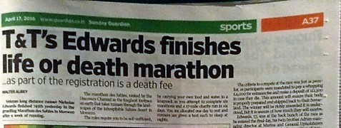

Wildlife: We are very fortunate in our local wildlife here in rural Ubbeston – little owls, tawny owls and barn owls are residents along with greater crested newts, bats and occasional otters and badgers. Herds of deer visit on a regular basis and many birds, including green and greater spotted woodpeckers, frequent our gardens and meadows. Every spring sees the welcome return of our families of swallows and house martins, although the latter seem to be declining in numbers lately.

One of our stars this year has been a little, now fully grown, female muntjac, who after her unfortunate road accident as a very tiny creature, was cared for by a local farm worker and taken to the RSPCA, who nursed her back to good health. This had two outcomes: the first that she was released back here in Ubbeston where she had been knocked down and is sporting an orange ear tag asking not to be eaten; the second that she has very little fear of humans. She has spent the year visiting members of the community in rotation and accepting pieces of apple (after chomping her way through another hosta plant, of course!) She found herself a mate over the summer but he was not nearly as trusting (which is a good thing) so there may be another little muntjac on its way. Our other stars are the newly resident pair of buzzards.
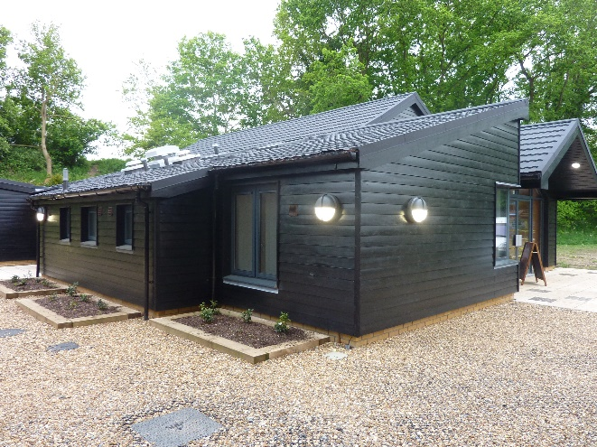
The Hub: The parishes of Huntingfield, Heveningham and Ubbeston, combined resources and names to produce the community centre called the Hub situated in Huntingfield. The building was opened on the 23rd April 2016 at a launch party attended by members of all three villages. The building replaces Huntingfield Village Hall, which was an old hut standing for nearly 100 years. Plays, music events, film shows, community celebrations, courses etc are all on offer at this beautiful venue. The leading figures became finalists in this year’s Enabling Communities Award.
Ubbeston hasn’t had a community centre since the early 1960’s when the last remaining of the two parish cottages on the B1117 opposite the Wheatsheaf was used as a parish room prior to being demolished.

Green Valley Farm: The house and lands changed hands this year and the previous owner allowed me to make a photographic record of the restoration to the grade II listed farmhouse and barn, which he had undertaken. I had previously photographed it some years earlier in 2007 soon after he moved in and before any restoration had taken place. One of the previous changes made in the 1970s was to remove a chimney. At that time children’s shoes, probably seventeenth century, were discovered under the fireplace and are now on display in Laxfield and District Museum. The barn dates from the seventeenth century and parts of the farmhouse from the late sixteenth century. There is a plaster over mantle upstairs dated 1678 with P I K spaced around the central fleur de lys.
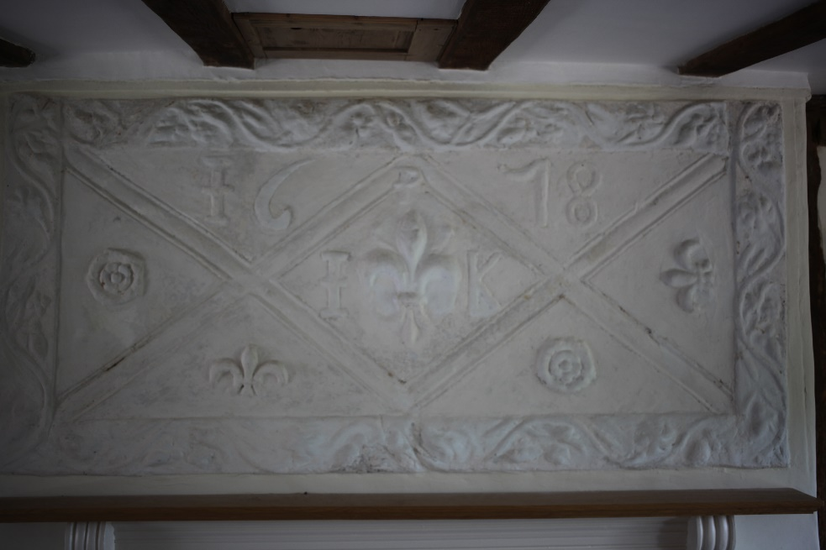
Lynne Ward, Ubbeston Recorder 30th December 2016

Appendix G

The Hub, Brick Kiln Lane, Huntingfield, Halesworth, IP19 0QH
www.huntingfield.org/the-hub. Registered Charity No. 1167467
Email: thehub@huntingfield.org
Telephone: 01986 799130

This time last year had just seen the official opening of The Hub, open to residents of all three villages. This was followed by a Business Launch in which we were delighted to welcome many people from various organisations who wanted to view The Hub and find out more about hiring it.

The landscaping is now complete including the new steps to the Millennium Green and planting on either side of the steps.

Now, a year on, The Hub's 1st Birthday Celebrations have been held and it is well established in the communities which it serves.

The Trustees naively thought that once The Hub was built and opened to the public the workload would decrease somewhat - not so! It was important that the needs of the community were met by organising classes, courses, events and social occasions. We were pleased to host events organised by the Millennium Green Trust and the Huntingfield Events Group as well as putting on many activities ourselves. It is a sign of how well the different groups in the village have pulled together that these activities have, by and large, been very successful.

So, what happens in The Hub - Pilates, Yoga, Jive & Swing, Zumba Gold, Bridge, Carpet Bowls, Wednesday Club, Youth Club, Table Tennis Club are all regular events and are interspersed with many different day courses, musical and theatre events, Apple Day, Race Night, Craft Fayre, Film Nights, Children's Xmas and Halloween Parties and so on. As well as these organised events The Hub has hosted many private parties and a wedding reception - our second one has just been booked!

There are still a couple of outstanding issues with the building itself which our contractors are working with us on but generally we are delighted with the standard or workmanship which has ensured a sound, aesthetically pleasing and economical building for the 21st Century.

Financially, it is very pleasing to be able to report not only 'breaking even' during the first year of operation but actually making a small profit, (unheard of in the first year of operation for most organisations!). This is due in no small part to the hard work of the Trustees in ensuring the hall is used to its full extent. We have been able to offer village groups, as well as individual villagers from all three communities, very reasonable hire rates to ensure its usage.

Having summarised the usage and finances it has to be said the Trustees are not complacent. We appreciate that with the diverse range of residents in the villages we are probably not servicing everyone as we would wish to do. We do implore people to LET US KNOW what you would like to see happening in The Hub. We are thinking of Bingo Nights, talks on various subjects, craft workshops as some possibilities. Please let us know what you would like to do in The Hub and we will do our best to accommodate it. This is very important as we are shortly to lose the Yoga Saturday morning sessions as they have not been well attended, as with the Children's Dance Class which went the same way some months ago. So, get in touch with any of the Trustees by leaving a message on the answerphone in The Hub 01986 799130, or email us on thehub@huntingfield.org.

Sue Lucas
Chair of The Hub CIO Trustees

Nick’s blog
ibid
ibid

