October/November 2023 Parish Report – Cllr Julia Ewart
East Suffolk Council GLI Group – Councillor Update

It is tricky to keep a pace with the monthly reports as things are so busy due to the impactful weather. Please do keep in touch as much as possible so that we are able to support all the villages. East Suffolk Council have many resources available.
Heavily impacted are Kelsale, Yoxford, rear of Peasenhall, Walpole and then many homes adjoining waterways of any and every nature. Please do speak up if impacted however small so that a measure might be made of the local pinch points.
Emergency Mobile 24/7 Julia Ewart – T 07770 666604 julia.ewart@eastsuffolk.gov.uk

Local Matters
Community Partnership (CP) – Talk Money
Yoxford Residents Are Extended An Invitation
The Kelsale and Yoxford ward CP is Sam Kenward. He is in post to bring three wards together including Kelsale & Yoxford. Rather like a project manager he works with his Councillors to highlight issues that need attention. He also hosts a meeting every 6 weeks and asks anyone from the wards to join in and support the progress of the area. We are working on mental health, rural transport and intergenerational opportunities. For Kelsale & Yoxford we have an event that is being promoted by the Senior Financial Inclusion Officer Megan Clifford and on Wed 8th November we are hosting a ‘Talk Money’ event at Kelsale Primary School from 8.30am for an hour in the new intervention room and at the Village Hall and club from 10am through till 2pm. This is an all age event. It will be marketed by the school and will also attract a mail drop from the council. IF it works then a further one will be put on higher up the ward to support Chediston, Cratfield, Linsteads etc and Walpole & Cookley.
Attending we hope to have
- Warm Homes team
- Citizens Advice
- Christians Against Poverty (CAP)
- Multiply Suffolk
- East Suffolk Council's Financial Inclusion team
Storm Babet and now Ciaran Storms Babet and Ciarán » East Suffolk Council
This event has been much discussed. In terms of this occasion, we need to review where each village is with the Environment Agency, relooking at each village’s commitments and their being ready for any future occurrence.
ESC are looking after the peripheral matters and the County the main ones. It is imperative for every village to work up an emergency plan using this link: c&p
Prepare your community - Suffolk Resilience Forum (suffolkprepared.co.uk)
Important links are:
Report a flood: Report a flood in Suffolk - Suffolk County Council
https://www.suffolk.gov.uk/roads-and-transport/flooding-and-drainage/report-a-flood-in-suffolk
ALL those homes flooded must report each flood to be able to claim any form of compensation.
How to use the link: Report a flood in Suffolk - Suffolk County Council. See the drop down menu and select reporting option as appropriate - I’d suggest in this instance using the ‘Flooding from Drains and ditches’ option (note link to a map showing information as already reported to Highways for flooding Suffolk County Council - ReportIT), just input say Kelsale, Tiggins Lane for example into the search bar when the link opens and this will show locations where flooding issues have already been reported.
These reports help to provide the SFRMP with sufficient information to present to the responsible authority who (if not a riparian land owner), should be able to respond regards clearing the material away from the bridges referred to and any others further downstream?
Recover from a flood: Flood Recovery information for Suffolk - Suffolk County Council
On top of these actions, Cllr Ewart has proposed to the council that villages are offered an Emergency kit, to include a number of emergency warning signs, grate lifts and drain rods, sandbags and a laminated sheet that has all the emergency numbers ready to use.
Here are the current instructions and support the villages from ESC as of 25/10/23:
Housing//
A number of homes, primarily in Framlingham and Wickham Market, are currently uninhabitable and our Housing Team are providing support to residents, in person, with officers currently based at the Castle Community Centre (Fram) and the village hall in Wickham Market.
If you are aware of any residents local to you - wherever this may be - who may require help of this nature, please ask them to ring our call centre telephone number 0333 016 2000. Residents of the two aforementioned locations will be advised to meet housing officers in person.
East Suffolk’s Communities Team is also assisting with ‘on the ground’ support and will continue to do so as long as is required.
Cleaning and clearing
East Suffolk Services (ESSL) has been deploying teams throughout the district to support communities whose properties have been affected, providing caged trucks to help dispose of damaged items as well as cleansing and sweeping of sewage and other detritus.
Again, residents are being urged to call 0333 016 2000 where they may require support. Residents will also be asked to ensure that they have checked with their insurance suppliers regarding necessary evidence for claims, prior to any disposal.
Given the intensity of the support required, this means that some services, such as normal bulky waste collections, may be impacted and residents are asked to remain patient.
Businesses
Economic Development colleagues are supporting businesses which have been affected by the storm. Colleagues have been contacting local business networks to establish need, particularly in Framlingham where a number of businesses have suffered loss and damage. Those affected are asked to email the team: economicdevelopment@eastsuffolk.gov.uk.
Economic Development can connect businesses with the appropriate support and are keen to establish how the Council can help support businesses in their recovery from the floods. The team are not able to offer financial support but can provide advice, based on specific need, which will include consideration for available funding support that may exist.

Support After the Flood – Special Grants
Data and funding
Following the Government’s announcement of financial support for those affected, the Joint Emergency Planning Unit (JEPU) is co-ordinating details of all affected properties in East Suffolk.

In summary, the funding schemes for Storm Babet are as follows:
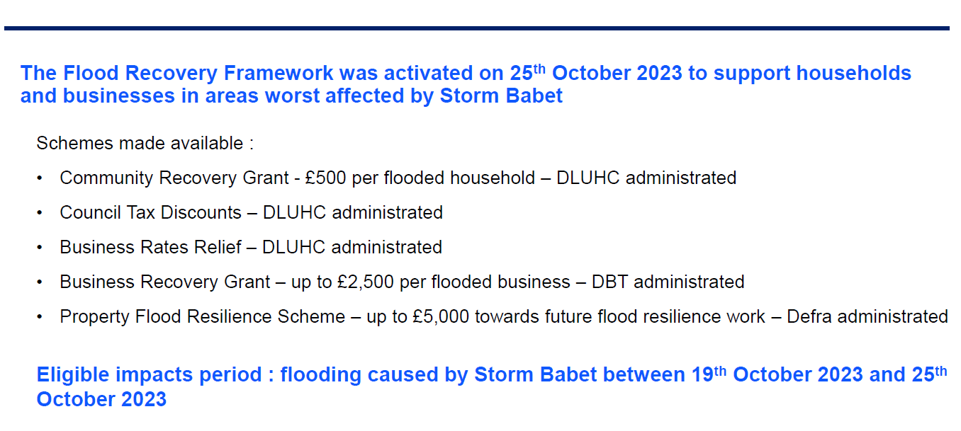
More information on the schemes administered by DLUHC (Dept of Levelling Up) below:
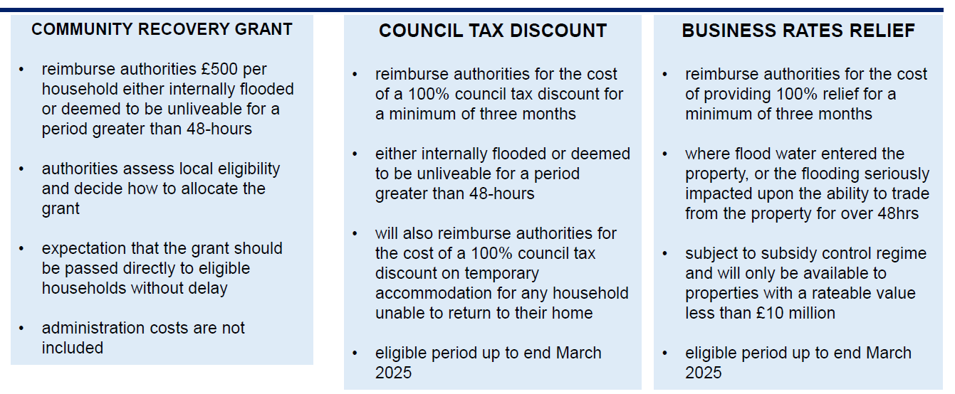

More detailed guidance will be issued this week (first week of November), with Government providing a format for the application of criteria. It will then be for local authorities to assess eligibility.

EDF & Sizewell C
The Energy Coast is now at a new level of progress and parishes are very concerned that the renewables programme is proving intense as a project to endure locally. We now need to get the best out of every situation. All parishes are encouraged to meet with EDF in their villages to ascertain what is likely to be the true impact. For those wishing to have a daily update then the tracker is available.
About - Sizewell C Works Tracker (szcworkstracker.co.uk) (press CTRL on the link)
Better PR is requested to stop locals having to second guess what is going on. There’s a concern about the new relief road and the small size of the roundabout currently planned. Kelsale is asked to be super vigilant about this detail.

OTHER NEWS
Businesses urged to have say in Explore Suffolk BID ballot
Update: Whilst the value of the bid was won in votes it was not won in weight and therefore has failed. As a Cllr of ESC I brought my concern of the BID process to the attention of Senior Councillors and asked that business in ES region should be informed more widely of their likely commitment financially if the bid were to go through – because I was concerned about the deliverable model and because of the current economy for businesses. Hence a press release was put out via my fellow Councillor. The BID system requires urgent national review as it’s a poorly governed process which compromises businesses if not run with integrity. Cllr Ewart
East Suffolk Council is urging local businesses to have their say in a ballot on the creation of a new ‘Destination Business Improvement District’ (BID), which includes parts of East Suffolk.
A ballot is being held by Locus Management Solutions Ltd to consider proposals for ‘Explore Suffolk’, which, in their words would seek “to connect businesses, partners and local authorities to establish a coherent tourism offer” and would see projects delivered over and above services already funded by councils. The BID is committing to champion the unique qualities of the South Suffolk area. This activity would be funded by a mandatory levy on businesses in the defined zone.
A Business Plan has been produced outlining key information about the proposal and all businesses entitled to vote should have received a statement with:
- an explanation for the arrangement of the ballot;
- an explanation of the regulations that allows the person to request a copy of the BID proposal;
- details of the name and address of the BID proposer.
If the ballot is carried, this business-led proposal will result in an additional 1.82% levy on business properties with a rateable value over £24,500. East Suffolk Council itself does not have a say in the process and has not been involved in the Advisory Board. But the Council is keen for businesses affected in East Suffolk to participate in the ballot, given the impact and requirement for them to fund the ‘Explore Suffolk’ BID.
GLI Cllr Vince Langdon-Morris, East Suffolk’s Cabinet Member for Resources and Value for Money, said: “I urge business owners who have received these BIDballot papers and voting forms to study the business case and participate in the vote. The BID area covers part of our district and includes locations already well served by the Felixstowe BID and “The Suffolk Coast” Destination Management Organisation (DMO). It is important that those businesses affected by the proposals are clear on the requirements and expectations, and we urge them to have their say.”
The ballot is taking place entirely by post and all votes must be returned by 5pm on Thursday 19 October 2023. If businesses entitled to vote have lost their ballot paper, then a replacement ballot paper can be obtained from Ipswich Borough Council. Information is available at: www.ipswich.gov.uk/BIDelections

Brownfield land grant to help pave way for waterfront regeneration
A Government grant worth more than £4.2million has been awarded to East Suffolk Council (ESC) to help transform brownfield land in Lowestoft into much needed future housing.
The £4,203,800 grant is part of the second phase of a £180m Brownfield Land Release Fund (BLRF) designed to unlock sites across the country to make way for more than 6,000 new homes. The funding will help cover the cost of land remediation at the former Sanyo and Survitec manufacturing sites located on the south side of Lake Lothing, Lowestoft, in an area known as Kirkley Waterfront.
The land was acquired by predecessor to ESC, Waveney District Council, in 2018, having stood vacant since 2009, and forms part of the Kirkley Waterfront and Sustainable Urban Neighbourhood scheme, which focuses on regenerating the area to provide housing and jobs for local people. The work will enable preparation for future development of plans which include the construction of 350 new homes at the former Sanyo and Survitec manufacturing sites.
GLI Cllr David Beavan, East Suffolk's Cabinet Member for Housing said: “This is good news. Lowestoft’s industrial past can be transformed into much needed housing which is as affordable and as sustainable as we can make it.
“Record homelessness needs more housing, which is better on brownfield than greenfield sites. We just need funding for the tidal barrier now to allow this project to go full steam ahead.”
Council pledges £900,000 investment for Town Hall restoration project
A project to restore and revitalise Lowestoft’s historic Town Hall has received a further funding boost thanks to a £900,000 investment by East Suffolk Council.
The funding will go towards a project to transform the vacant High Street building into a multi-functional community space, containing a Heritage Gallery, café, community event space and town council offices. On Tuesday, Cabinet members agreed a request from building owner and project leader, Lowestoft Town Council, for a financial contribution towards the redevelopment, which forms part of the Lowestoft Town Investment Plan and the Towns Fund programme.
The building occupied by the former Waveney District Council until 2015, when operations moved to new Riverside offices, and was transferred to Lowestoft Town Council in 2017. East Suffolk Council has already provided support in developing the project plan and bidding for additional external funding, which included an allocation of £2million in Towns Fund investment as part of the overall £24.9m Lowestoft’s Town Deal awarded by the Department for Levelling Up, Homes & Communities (DLUHC) in 2022. Last month, the project received another major £3,257,512 funding boost from The National Lottery Heritage Fund as part of a £12.2m investment to help restore 12 historic buildings nationwide.
GLI Cllr Toby Hammond, East Suffolk’s Cabinet Member for Economic Development and Transport, said: “We are delighted to be able to agree this further investment in the Lowestoft Town Hall regeneration project, which promises to maintain the listed building’s character, while greatly increasing its uses and maximising sustainability.”
Comment on permit for incineration plant
An application for an environmental permit has been submitted to East Suffolk Council for a small waste incineration plant at Ellough, near Beccles and residents are invited to submit their views.
The proposal to build and operate a Small Waste Incineration Plant (SWIP) in Ellough was submitted to Suffolk County Council and planning permission was granted in May 2023. This plant will be owned, constructed and managed by V.C. Cooke Ltd alongside their existing waste operation on the Ellough Industrial Estate. In law, as well as planning permission for a waste incinerator, the operators need to obtain a permit to ensure it operates with minimal pollution. V.C. Cooke Ltd have now applied to East Suffolk Council for this permit, and provided information about how the site will be built and controlled. The Council’s Environmental Protection team will now follow a strict process to assess whether the application proves the SWIP will not cause harm to human health or the environment.
Residents are invited to take part in the consultation and provide any information or facts about the site that may not be included in the application paperwork. This ensures the Council has fully assessed how the operator intends to manage the incinerator.
Any comments on the application should be emailed to ep@eastsuffolk.gov.uk or sent by post to Environmental Protection, East Suffolk Council, Riverside, Canning Road, Lowestoft, NR33 0EQ. Any written comments will be placed on the public register unless they include a statement requesting that this is not done.
The consultation closes on 5 November 2023.
The application can be viewed at: www.eastsuffolk.gov.uk/features/comment-on-permit-for-incineration-plant/

For the most up to date information regarding East Suffolk Council, please visit: www.eastsuffolk.gov.uk
-----------------------------------------------------------------------------------------------------------
Useful Emergency Numbers

Fallen trees, emergency: 0345 606 6171

Highway flooding: SCC 0345 606 6171 or 0300 1235000 or use the Highways reporting tool on SCC website www.highwaysreporting.suffolk.gov.uk

Street cleaning/clearing: 0333 016 2000

Power cut : Power Networks call 105 or 999

Dangerous structure: 01394 444 219 out of hours 0800 440 2516

Manhole problems are considered an emergency: 0345 606 6171

Leaks, Anglian Water: 24/7 0345 145 145

Emergency out of Hours ESC number is :0800 440 2516

